**ROUND 5: HAEMATOLOGY (50 points )**

**CASE STUDY 1** (12 points)

A 73-year-old woman develops shingles (herpes zoster infection) in the right T7 dermatome. She attends her GP who also notices that she has palpable lymph nodes in the right cervical region. The GP undertakes a full blood count, which shows the following:  
Hb 131 g/dL; WBC 27.7 × 109/L; Lymphocytes 82%; Platelets 277 × 109/L; Blood film – predominance of mature lymphoid cells.

1. **What is the likely diagnosis?** (2 points)
2. **What further tests** (at least 2) **would you undertake and what results would be expected in this diagnosis?** (4 points)
3. **What treatment would you institute?** (2 points)
4. **What complications can occur** (at least 3)**?** (3 points)
5. **What is the long-term prognosis of this condition?** (1 point)

**CASE STUDY 2** (10 points)

**Question 1** (1 point)

Obrázok, na ktorom je fialka, lila (farba), tmavopurpurová, pestrofarebnosť

Obsah vygenerovaný umelou inteligenciou môže byť nesprávny.

A previously healthy 26-year-old man has had a low-grade fever, malaise, and sore throat for the past 2 weeks. On physical examination his temperature is 37.5°C. He has a pharyngitis and generalized tender lymphadenopathy. His peripheral blood smear is shown here.

**Which of the following is the most likely risk factor for his illness?**

A  Inherited disorder of globin chain synthesis

B  Transfusion of packed red blood cells

C  Close personal contact (kissing) with his date

D  Sharing infected needles for injection drug use

E  Undergoing chemotherapy for testicular carcinoma

F  Mutation arising in a BCL-2 gene

**Question 2** (1 point)

Obrázok, na ktorom je purpurový, lila (farba), fialka, látka

Obsah vygenerovaný umelou inteligenciou môže byť nesprávny.

A 60-year-old woman has become increasing tired and 'run down' over the past 6 months. On physical examination she has a palpable spleen tip and non-tender axillary lymphadenopathy. Laboratory studies show Hgb 10.1 g/dL, Hct 30.5%, MCV 90 fL, platelet count 89,000/uL, and WBC count 31,300/uL. Her peripheral blood smear is shown here.

**Which of the following is the most likely diagnosis?**

A  Infectious mononucleosis

B  Chronic lymphocytic leukemia

C  Iron deficiency anemia

D  Bacterial septicemia

E  Systemic lupus erythematosus

F  Varicella-zoster virus infection

**Question 3** (1 point)

Obrázok, na ktorom je purpurový, fialka, lila (farba), pestrofarebnosť

Obsah vygenerovaný umelou inteligenciou môže byť nesprávny.

A 30-year-old man has noted a progressively worsening cough for one month. On physical examination, a few small lymph nodes are palpable in his axillae, and the tip of the spleen is palpable. Laboratory studies show Hgb 10.2 g/dL, Hct 31.1%, MCV 90 fL, WBC count 67,400/microliter, and platelet count 36,220/microliter. His peripheral blood smear is shown here.

**Which of the following is the most likely diagnosis?**

A  Acute myelogenous leukemia

B  Plasma cell leukemia

C  Chronic lymphocytic leukemia

D  Acute lymphoblastic leukemia

E  Hairy cell leukemia

F  Leukoerythroblastosis

**Question 4** (1 point)

Obrázok, na ktorom je fialka, levanduľa, lila (farba), purpurový

Obsah vygenerovaný umelou inteligenciou môže byť nesprávny.

A 61-year-old man has had back pain for 5 months. He recently developed a cough productive of yellowish sputum. On physical examination he has no lymphadenopathy or splenomegaly. His temperature is 37.8°C. A radiograph of the spine reveals several 1 to 2 cm lytic lesions of the vertebral bodies. His serum urea nitrogen is 28 mg/dL and creatinine 3.0 mg/dL. A sputum culture grows *Streptococcus pneumoniae*. A bone marrow biopsy is performed, and the marrow smear is shown here.

**Which of the following laboratory test findings is most likely to be present in this man?**

A  Markedly elevated D-dimer

B  Tear drop cells in peripheral blood

C  Decreased leukocyte alkaline phosphatase

D  Decreased CD4 lymphocyte count

E  Hypergammaglobulinemia

**Question 5** (1 point)

Obrázok, na ktorom je lila (farba)

Obsah vygenerovaný umelou inteligenciou môže byť nesprávny.

A 26-year-old man has the sudden onset of severe chest, back, and abdominal pain. On physical examination he is afebrile. He has no lymphadenopathy or splenomegaly. He has right upper quadrant tenderness. His peripheral blood smear is shown here.

**Which of the following conditions is he most likely to have?**

A  Epstein-Barr virus infection

B  Chronic atrophic gastritis

C  Pigmented gallstones

D  Hepatitis A infection

E  Esophageal web

F  Inflammatory bowel disease

**Question 6** (1 point)

Obrázok, na ktorom je jedlo, mäso

Obsah vygenerovaný umelou inteligenciou môže byť nesprávny.

A 78-year-old woman has felt tired for the past 4 months. On physical examination there are no abnormal findings. Laboratory studies show Hgb 10.6 g/dL, Hct 29.8%, MCV 92 fL, platelet count 95,000/uL, and WBC count 4,900/uL. The WBC differential count shows 67 segs, 4 bands, 2 metamyelocytes, 22 lymphs, 5 monos, and 2 nucleated RBC's per 100 WBC's. This gross appearance is representative of this patient's disease.

**Which of the following is the most likely diagnosis?**

A  Beta thalassemia

B  Chronic lymphocytic leukemia

C  Bacterial septicemia

D  Myelofibrosis

E  Alpha thalassemia

F  Metastatic carcinoma

**Question 7** (1 point)

Obrázok, na ktorom je ošatenie, látka, lila (farba), vzor

Obsah vygenerovaný umelou inteligenciou môže byť nesprávny.

A 27-year-old woman is brought to the emergency department after she suddenly collapsed. On physical examination her temperature is 37.1°C, pulse 100/minute, respiratory rate 20/minute, and blood pressure 80/40 mm Hg. Laboratory studies show a positive pregnancy test. Her peripheral blood smear is shown here.

**Which of the following is the most likely diagnosis?**

A  Metastatic adenocarcinoma

B  Mycobacterium tuberculosis infection

C  Hodgkin lymphoma, nodular sclerosis type

D  Acute lymphocytic leukemia

E  Disseminated intravascular coagulation

**Question 8** (1 point)

Obrázok, na ktorom je purpurový

Obsah vygenerovaný umelou inteligenciou môže byť nesprávny.

A 32-year-old woman has had fatigue, fever, and night sweats for the past month. On physical examination her temperature is 37.7°C. She has painless right cervical adenopathy. A cervical lymph node biopsy is performed and the microscopic appearance is shown here.

**Which of the following is the most likely diagnosis?**

A  Hodgkin lymphoma, nodular sclerosis type

B  Well-differentiated lymphocytic lymphoma

C  Benign reactive lymphoid hyperplasia

D  Burkitt lymphoma

E  Disseminated cytomegalovirus infection

**Question 9** (1 point)

Obrázok, na ktorom je lila (farba), fialka, tmavopurpurová, pestrofarebnosť

Obsah vygenerovaný umelou inteligenciou môže byť nesprávny.

A 65-year-old man has noted a lump in his armpit for the past 3 months. On physical examination he has non-tender axillary lymphadenopathy. A lymph node biopsy is performed and the microscopic appearance is shown here.

**Which of the following is the most likely diagnosis?**

A  Metastatic carcinoma

B  Multiple myeloma

C  Reactive hyperplasia

D  Lymphocytic lymphoma

E  Letterer-Siwe disease

F  Cat scratch disease

**Question 10** (1 point)

Obrázok, na ktorom je látka, ošatenie, baliaci papier, vzor

Obsah vygenerovaný umelou inteligenciou môže byť nesprávny.

A 79-year-old woman has become increasingly lethargic for the past 6 months. On physical examination she is afebrile. Her peripheral blood smear is shown here.

**Which of the following findings reported on a CBC is most likely to be present in this woman?**

A  Platelet count of 540,000/microliter

B  Mean corpuscular volume of 72 femtoliters

C  Hematocrit of 55%

D  Mean corpuscular hemoglobin concentration of 36.5 picograms/microliter

E  Red cell distribution width of 9.8%

**CASE STUDY 3** (28 points)

**ANEMIA**

1. **What is anemia? What 3 laboratory paramateres are used for diagnosing anemia and what are their values in both male and female?** (7 points)
2. **What are the sites of absorption of iron and vitamin B12?** (3 points)
3. **Briefly describe the process of erythropoesis.** (4points)
4. **In ineffective erythropoiesis, what 3 types of anemia are there based on the size of the erythrocyte? Describe each briefly.** (6 points)
5. **Name and briefly describe the hemoglobinopathy on the picture below.** (2 points)

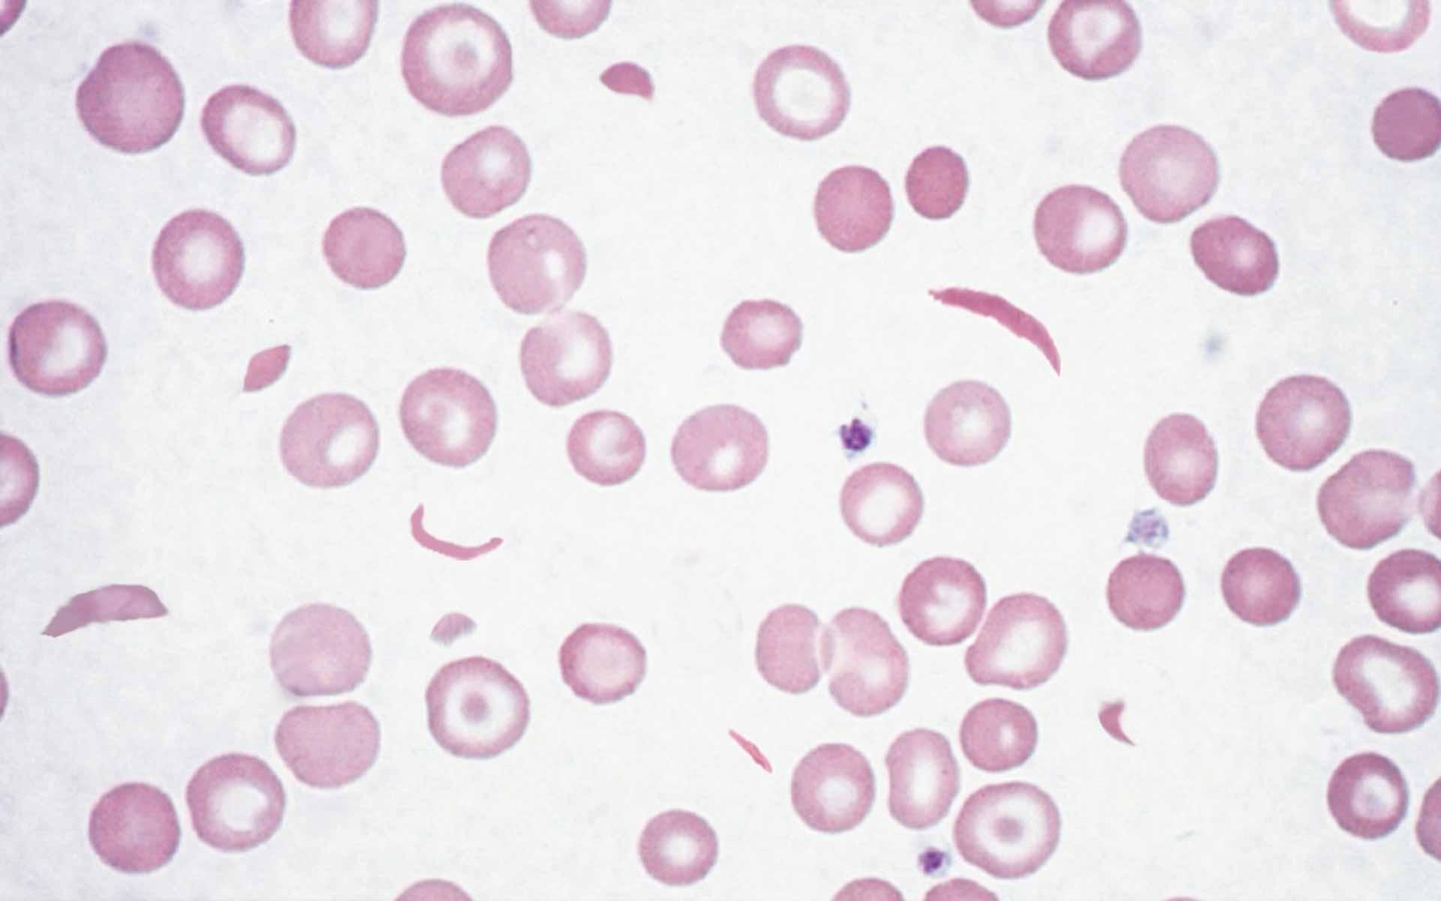

1. **Briefly describe Thalassemias.** (4 points)
2. **What 2 diagnosis would you give in the following 2 case studies?** (2 points)

**Case Study 1:** A 72 year old male has the CBC findings shown. Peripheral RBCs are

hypochromic and microcytic.

Obrázok, na ktorom je text, diagram, čierno-biela

Obsah vygenerovaný umelou inteligenciou môže byť nesprávny.

Obrázok, na ktorom je purpurový, lila (farba), fialka, vzor

Obsah vygenerovaný umelou inteligenciou môže byť nesprávny. Obrázok, na ktorom je lila (farba), purpurový, fialka, ružová

Obsah vygenerovaný umelou inteligenciou môže byť nesprávny.

**Case Study 2:** A 48 year old male has become progressively more fatigued at the end of the day. This has been going on for months. In the past month he has noted paresthesias with numbness in his feet. A CBC demonstrates the findings shown.

Obrázok, na ktorom je text, diagram, čierno-biela

Obsah vygenerovaný umelou inteligenciou môže byť nesprávny.

A peripheral blood smear ( the picturew below) shows red blood cells displaying macro- ovalocytosis and neutrophils with hypersegmentation.

Obrázok, na ktorom je fialka, purpurový, snímka obrazovky, pestrofarebnosť

Obsah vygenerovaný umelou inteligenciou môže byť nesprávny. Obrázok, na ktorom je lila (farba), fialka, tmavopurpurová, pestrofarebnosť

Obsah vygenerovaný umelou inteligenciou môže byť nesprávny.